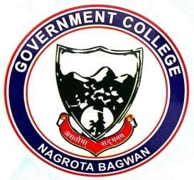
GOVERNMENT COLLEGE
NAGROTA BAGWAN
Distt. Kangra (H.P.)-176047
Tel.: 01892-251177
EMAILID: gcnagrotabagwan@gmail.com

Link for Webpage Describing the ICT Enabled Tools for Effective Teaching-Learning Process
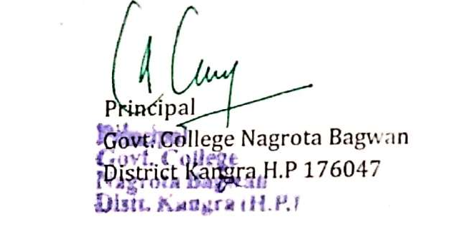

http://gdcnb.org/ict-tools/

